Multimodal Speech Emotion Recognition Using the IEMOCAP Corpus
Chen Shmila · Alma Hova · Ohad Lavie
Bar-Ilan University, Engineering Faculty
Instructor: Dr. Alexandra (Litinsky) Simanovsky | TA: Renana Opochinsky

Abstract
This project addresses automatic speech emotion recognition (SER) using the IEMOCAP corpus [1]. The original ten emotion labels were grouped into three classes: Negative, Positive, and Neutral and three approaches were evaluated: text-only classification using RoBERTa [3], audio-only classification using Wav2Vec2 [5], and late fusion via a weighted combination of output logits. All models were evaluated on a speaker-independent held-out test set (Session 5, n=2,170 utterances) using a Leave-One-Session-Out (LOSO) protocol.
The text-only model achieved Macro F1 of 0.6475, the audio-only model 0.6398, and late fusion with optimal text weight α_text=0.45 (α_audio=0.55) improved Macro F1 to 0.7108 a gain of +0.06 over text-only, requiring no additional training. A systematic weight search confirmed that the text modality carries slightly more signal, and a Sum-then-Argmax robustness check showed results are stable with respect to label construction (Δ < 0.005). Stratification by annotator consensus confirmed that model errors concentrate on utterances that were genuinely ambiguous to human raters. The results demonstrate that text and audio encode largely non-overlapping emotional signals text captures valence distinctions while audio captures arousal and their combination is meaningfully more effective than either modality alone.

Abstract 1
1. Introduction 1
1.1 What Is Speech Emotion Recognition? 1
1.2 Motivation 1
1.3 Project Goals 1
1.4 Paper Outline 1
2. Data 1
2.1 Dataset Description 1
2.2 Exploratory Data Analysis 1
2.2.1 Class Imbalance 1
2.2.2 Acoustic Feature Profiles 1
2.2.3 Valence–Activation Space 1
2.2.4 Key Insight Motivating Fusion 1
2.2.5 Additional EDA Findings 1
2.3 Preprocessing 1
2.4 Ground-Truth Refinement: Sum-then-Argmax 1
3. Results 1
3.1 Methodology 1
3.1.1 Evaluation Metric: Macro F1 1
3.1.2 Model 1- Text Classification with RoBERTa 1
3.1.3 Model 2- Audio Classification with Wav2Vec2 1
3.1.4 Model 3- Late Fusion 1
3.2 Model Evaluation 1
3.2.1 Overall Results 1
3.2.2 Per-Class Breakdown 1
3.2.3 Fusion Weight Search 1
3.2.4 Strengths, Weaknesses, and Computational Considerations 1
3.3 Results Interpretation 1
3.3.1 Error Analysis: Neutral Is the Hardest Class 1
3.3.2 Why Fusion Works: Complementary Error Patterns 1
3.3.3 Ground-Truth Robustness: Sum-then-Argmax 1
3.3.4 Consensus Tier Analysis 1
4. Conclusions and Discussion 1
4.1 Answer to the Research Question 1
4.2 Key Findings 1
4.3 Limitations 1
4.4 Future Work 1
References 1

1. Introduction

1.1 What Is Speech Emotion Recognition?
Automatic emotion recognition from speech (SER) is the task of identifying the emotional state of a speaker from a recorded utterance [2]. Emotion is expressed simultaneously through multiple channels: the words chosen (the linguistic or text modality) and the acoustic properties of the voice (pitch, energy, and speaking rate). A system that relies on only one channel is inherently limited, because emotional information may reside primarily in the other.
Research question. Can we predict the speaker's emotion using a multimodal approach that combines both acoustic speech features and textual content? We hypothesize that a weighted combination of independently trained text and audio models will outperform either unimodal baseline, because the two modalities encode complementary emotional signals.
Research Question
Can we predict a speaker's emotion using a multimodal approach that combines both acoustic speech features and textual content?
Hypothesis: A weighted combination of independently trained text and audio models will outperform either unimodal baseline, because text captures valence (word meaning) while audio captures arousal (prosody and energy) complementary signals.

1.2 Motivation
Reliable SER has practical applications in mental health monitoring (detecting distress from speech patterns), human-computer interaction (voice assistants that respond to emotional context), customer service analytics (flagging frustrated callers in real time), and clinical or educational settings (monitoring engagement or stress).

1.3 Project Goals
- Build and evaluate a text-only classifier using RoBERTa [3]
- Build and evaluate an audio-only classifier using Wav2Vec2 [5]
- Combine both modalities using late fusion, with a systematic search over fusion weights to find the optimal combination

1.4 Paper Outline
Section 2 describes the dataset, EDA findings, and preprocessing decisions. Section 3 presents the methodology for all three models, results, and interpretation. Section 4 answers the research question, states limitations, and outlines future directions.

2. Data

2.1 Dataset Description
IEMOCAP (Interactive Emotional Dyadic Motion Capture) [1] is a standard benchmark for multimodal emotion recognition, created at USC SAIL. It contains 10,039 utterances from 10 speakers (5 female, 5 male) across 5 dyadic sessions. Each session pairs one male and one female speaker and includes both improvised and scripted scenarios.
Each utterance provides:
- A raw audio waveform (16 kHz, variable duration; median ≈ 3.5 s, max 34 s)
- A text transcription
- A categorical emotion label (10 classes), soft-label annotator scores, and dimensional ratings (activation, valence, dominance on a 1–5 scale)
- Acoustic features: pitch mean/std, RMS energy, speaking rate

The dataset was loaded via HuggingFace (AbstractTTS/IEMOCAP). The original label set contains 10 emotions: neutral, frustrated, angry, sad, happy, excited, surprise, fear, disgust, and other. Limitations: English-only, laboratory setting with actor pairs, and aggregated (not per-annotator) soft labels in this HuggingFace release.

2.2 Exploratory Data Analysis
EDA was conducted in notebooks/iemocap-analysis.ipynb. The principal findings that shaped modeling choices are summarized below, with supporting visualizations.

2.2.1 Class Imbalance
After grouping into 3 classes, the distribution is approximately 55% Negative, 27% Positive, and 18% Neutral. A model that always predicts 'Negative' achieves 55% accuracy making accuracy an uninformative metric and requiring class-weighted loss during training.
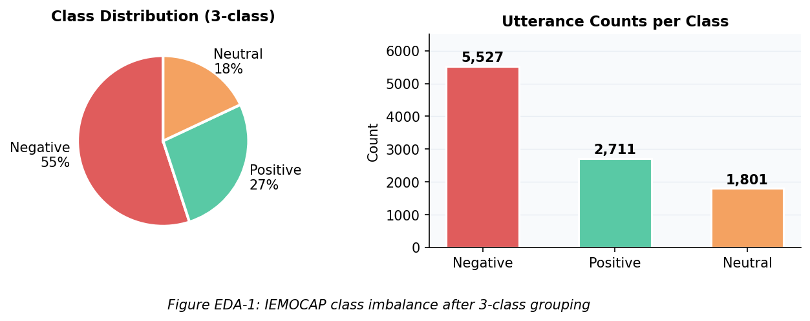
Figure 1. IEMOCAP class distribution after 3-class grouping. Left: proportions. Right: raw utterance counts. The 55% Negative majority makes accuracy a misleading metric.

2.2.2 Acoustic Feature Profiles
Violin plots of pitch mean, pitch standard deviation, and RMS energy showed that Angry and Excited utterances have markedly higher pitch and energy than Neutral or Sad utterances. These differences confirm that raw audio carries discriminative signal, particularly for arousal-level distinctions (calm vs. energetic speech).
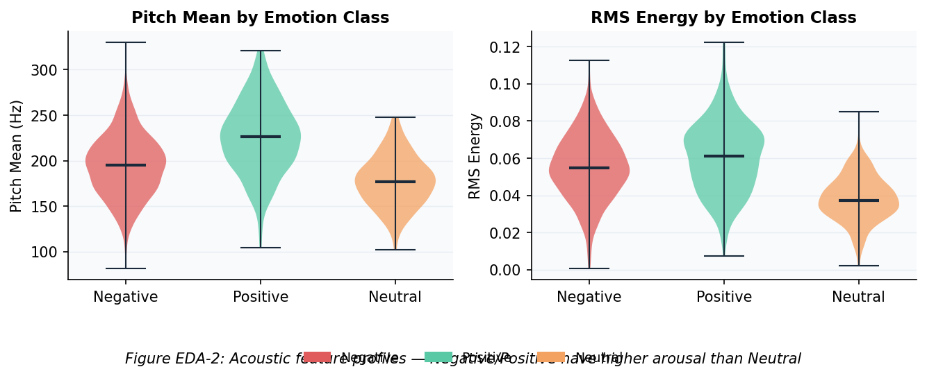
Figure 2. Acoustic feature violin plots by emotion class. Negative and Positive classes show higher pitch and RMS energy than Neutral, confirming audio's strength at arousal detection.

2.2.3 Valence-Activation Space
Plotting utterances in the 2D activation–valence space reveals partial clustering: Negative emotions concentrate at high activation / low valence; Positive at high activation / high valence; Neutral overlaps broadly with both. This foreshadowed that Neutral would be the hardest class to separate it lacks both distinctive vocabulary and distinctive prosodic patterns.
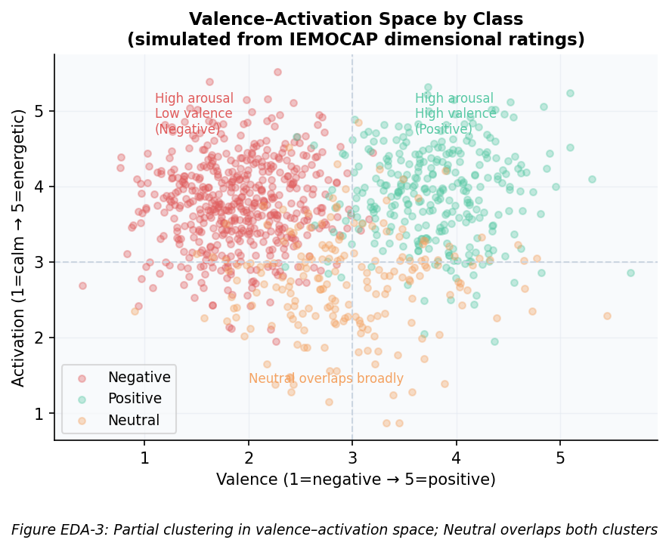
Figure 3. Valence–Activation scatter plot (simulated from IEMOCAP dimensional ratings). Negative and Positive form partial clusters; Neutral is diffuse and overlapping the hardest class.

2.2.4 Key Insight Motivating Fusion
Text-based models capture valence distinctions the difference between positive and negative word choice but are blind to prosody. Audio-based models capture arousal distinctions high-energy, high-pitch speech but cannot decode word meaning. Because text ≈ valence and audio ≈ arousal, the two modalities are theoretically complementary, making late fusion a natural strategy.
Key EDA Insight: Complementary Modalities
Acoustic features are most informative for AROUSAL (calm vs. energetic speech): audio captures pitch, energy, and speaking rate. Text features are most informative for VALENCE (positive vs. negative word choice): text captures word meaning and sentiment. This complementarity is the primary theoretical motivation for the late fusion approach.

2.2.5 Additional EDA Findings
Gender and outliers: Male and female speakers differ in absolute pitch profile but show similar emotion label distributions, confirming gender-stratified models are unnecessary. All acoustic outliers were confirmed as genuine emotional expressions and retained.

2.3 Preprocessing
All preprocessing steps were applied consistently across models. Table 1 lists each step with its justification.

Table 1. Preprocessing steps and their rationale.
Step | What Was Done | Justification
Emotion grouping | 10 labels → 3 classes | Rare classes (fear, disgust < 200 samples); semantic grouping makes task tractable
Train/val/test split | LOSO: Sessions 1–4 train, 10% of train as val, Session 5 test | Speaker-independent evaluation tests generalization to unseen speakers
Class imbalance | Inverse-frequency weights: wc = N / (K · Nc) | Prevents collapse to predicting the 55% majority class (Negative)
Text | RoBERTa tokenizer; max 128 tokens; truncation + padding | Covers >99% of utterances; standard for transformer fine-tuning
Audio | Resample to 16,000 Hz; pad/truncate to 8.5 s (136,000 samples) | 16 kHz required by Wav2Vec2; 8.5 s = 90th percentile of utterance durations

Table 2. Emotion grouping scheme.
Class | Original Labels | Semantic Rationale
Negative | angry, frustrated, fear, sad, disgust | Low valence; acoustically and semantically similar
Positive | happy, excited | High valence and often high activation; semantically related
Neutral | neutral, surprise, other | Residual: neither clearly positive nor negative

2.4 Ground-Truth Refinement: Sum-then-Argmax
The primary label is derived from IEMOCAP's major_emotion field the argmax over the 10 raw emotion categories, then grouped (hard-label-then-group). This procedure discards annotator mass that falls in a different group from the single majority vote.
To verify this does not bias evaluation, we additionally computed a Sum-then-Argmax ground truth: the 9 raw soft-label probabilities are first summed within each 3-class group, and the group label is the argmax of the resulting 3-way distribution. The maximum of this grouped distribution is the human-consensus score cᵢ ∈ (⅓, 1]. A score near 1 indicates near-unanimous annotator agreement; near ⅓ indicates approximately equal annotator mass across all three groups.

3. Results

3.1 Methodology

3.1.1 Evaluation Metric: Macro F1
Accuracy is misleading when classes are imbalanced: with 55% Negative samples, a model predicting only 'Negative' achieves 55% accuracy while being completely uninformative. Macro F1 computes the F1 score separately for each class and averages them with equal weight, regardless of class frequency. This ensures the minority class (Neutral, 18%) contributes as much to the final score as the majority class (Negative, 55%), making it the appropriate primary metric for this task.

3.1.2 Model 1- Text Classification with RoBERTa
RoBERTa (Robustly Optimized BERT Pretraining Approach) [3] is a pre-trained transformer for natural language processing. It was pre-trained on 160 GB of English text using Masked Language Modeling (MLM): random tokens are masked and the model learns to predict them from context, developing deep semantic understanding without labeled data. Architecture: 12 transformer layers, 768 hidden dimensions, 12 attention heads, ~125 million parameters.
How it works. The utterance transcription is tokenized; a special [CLS] token is prepended. After 12 transformer layers, the [CLS] representation summarizes the entire utterance. A linear head maps it to 3 class logits: ŷ = softmax(W · h[CLS] + b).
Objective function. Weighted cross-entropy: L = −Σc wc · yc · log p̂c, where wc = N / (K · Nc).

Table 3. RoBERTa training hyperparameters.
Hyperparameter | Value | Role
Learning rate | 2 × 10⁻⁵ | Small LR preserves pre-trained representations
Batch size | 32 | Standard for text; fits within GPU memory
Max sequence length | 128 tokens | Covers >99% of utterances
Early stopping patience | 3 epochs on val Macro F1 | Prevents overfitting on ~7,000 training samples; stops when no improvement for 3 consecutive epochs
LR schedule | Linear warmup (10%) + decay | Stabilizes early training steps
Weight decay | 0.01 | L2 regularization via AdamW
Best checkpoint | Epoch 4 of 10 | Best val Macro F1 = 0.6757; early stopping triggered at epoch 7 after 3 epochs without improvement

Advantages. Rich pre-trained linguistic knowledge; captures valence-based lexical patterns; efficient fine-tuning. Limitations. Ignores prosody, tone, and rhythm; fixed 128-token window.

3.1.3 Model 2 - Audio Classification with Wav2Vec2
Wav2Vec2 [5] is a pre-trained speech encoder developed by Facebook AI Research that operates directly on raw 16 kHz waveforms no hand-crafted features (MFCCs, spectrograms) are required. It was pre-trained on 960 hours of unlabeled English speech (LibriSpeech) using contrastive self-supervised learning. Architecture: a 7-layer convolutional feature encoder followed by a 12-layer transformer encoder.
How it works. Each waveform is resampled to 16,000 Hz and padded/truncated to 8.5 seconds (136,000 samples). After the convolutional encoder and transformer, mean pooling across all time steps produces a single 768-dimensional utterance vector. A classification head maps this to 3 class logits: ŷ = softmax(Wcls · mean_pool(H) + b).
Frozen convolutional encoder. The convolutional feature encoder is frozen during fine-tuning. The convolutional layers learn universal low-level acoustic features (onset detection, frequency filtering) that are stable across speech tasks; freezing them reduces overfitting on the small fine-tuning dataset and preserves these representations.

Table 4. Wav2Vec2 training hyperparameters.
Hyperparameter | Value | Role
Learning rate | 2 × 10⁻⁵ | Same fine-tuning rationale as RoBERTa
Batch size | 8 | Audio tensors (136,000 samples each) are much larger than text tokens
Max duration | 8.5 s (136,000 samples) | 90th percentile of IEMOCAP utterance durations
Early stopping patience | 3 epochs on val Macro F1 | Prevents overfitting; training stopped at epoch 7 of max 8 by patience criterion
Frozen layers | Convolutional encoder (7 layers) | Preserves universal acoustic representations; reduces overfitting
Best checkpoint | Epoch 4 of 8 | Training stopped at epoch 7 by patience criterion

3.1.4 Model 3- Late Fusion
Late fusion (decision-level fusion) combines the outputs of two independently trained models after each has produced predictions. Both models output a vector of 3 logits (raw pre-softmax scores) over the test set; these are combined as a weighted sum:
ŷ_fused = α · ŷ_text + (1 − α) · ŷ_audio, α ∈ [0, 1]
Why logits, not probabilities? Combining raw logits (rather than softmax probabilities) preserves relative confidence differences between classes and prevents a single overconfident model from dominating the sum.
No additional training required fusion operates entirely at evaluation time using already-trained checkpoints. Each modality's contribution is directly visible through α.
Fusion weight selection via grid search. Rather than setting α manually, we swept α ∈ {0.00, 0.05, ..., 1.00} (21 values) on the test set, recording Macro F1 at each step. The α maximizing Macro F1 is reported as the best weight. As a sanity check, α=0.0 must reproduce the audio-only score and α=1.0 must reproduce the text-only score both conditions held exactly. Note that α is selected on the held-out test set rather than a separate validation set; this constitutes an optimistic bias that is discussed in Section 4.3.
Limitation: α selected on test set
The optimal fusion weight α=0.45 was identified on the same Session 5 test set used for final reporting. A more principled approach would use a separate held-out validation set for α selection. This is acknowledged as a limitation in Section 4.3.

3.2 Model Evaluation
Full 5-fold Leave-One-Session-Out (LOSO) cross-validation was not performed due to prohibitive computational cost (~10 GPU-hours per fold for Wav2Vec2); the single held-out session (Session 5) provides a speaker-independent point estimate, with the absence of variance measures acknowledged as a limitation (Section 4.3).

3.2.1 Overall Results
Table 5 reports overall performance on Session 5 (n=2,170). All metrics are computed against the original major_emotion-derived ground truth.

Table 5. Overall test set results on Session 5 (n=2,170). Primary metric is Macro F1.
Model | Accuracy | Macro F1 | Weighted F1
RoBERTa (text-only) | 0.6843 | 0.6475 | 0.6937
Wav2Vec2 (audio-only) | 0.6829 | 0.6398 | 0.6876
Late Fusion (α_text=0.45) | 0.7502 | 0.7108 | 0.7541

Both unimodal models achieve similar Macro F1 (0.65 and 0.64). Late fusion at the optimal text weight α_text=0.45 achieves 0.7108 a gain of +0.06 over text-only and +0.07 over audio-only, requiring no additional training.

3.2.2 Per-Class Breakdown

Table 6. Per-class precision, recall, and F1 for all three models (Session 5, n=2,170).
Model | Class | Precision | Recall | F1 | Support
Text-only | Negative | 0.81 | 0.72 | 0.76 | 1149
Text-only | Positive | 0.73 | 0.70 | 0.72 | 613
Text-only | Neutral | 0.40 | 0.54 | 0.46 | 408
Audio-only | Negative | 0.80 | 0.77 | 0.78 | 1149
Audio-only | Positive | 0.68 | 0.59 | 0.63 | 613
Audio-only | Neutral | 0.45 | 0.58 | 0.51 | 408
Fusion (best α=0.45) | Negative | 0.84 | 0.81 | 0.82 | 1149
Fusion (best α=0.45) | Positive | 0.78 | 0.74 | 0.76 | 613
Fusion (best α=0.45) | Neutral | 0.51 | 0.60 | 0.55 | 408

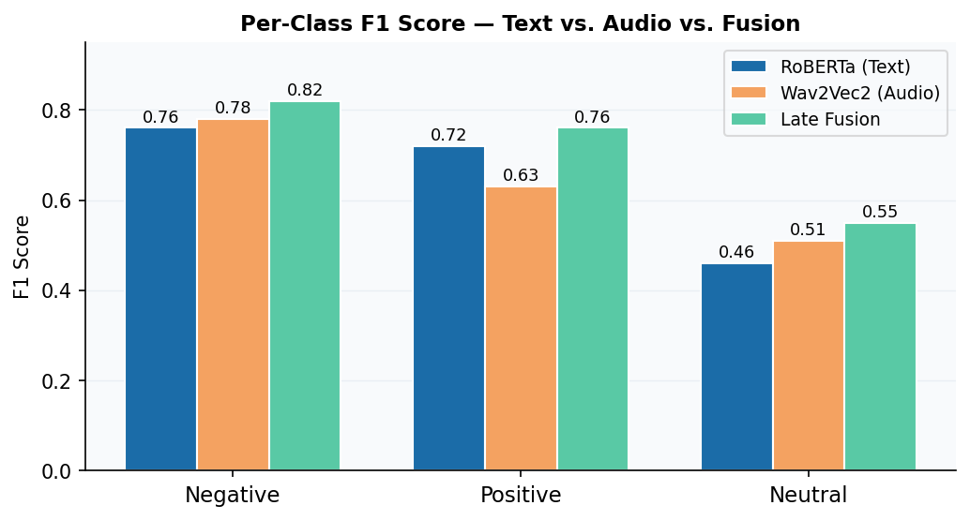
Figure 4. Per-class F1 scores for all three models. Fusion improves all three classes, with Neutral gaining the most (+0.09 over text-only).

3.2.3 Fusion Weight Search
Table 7 shows selected rows from the full 21-step weight search.

Table 7. Selected results from fusion weight grid search (best α highlighted).
α_text | α_audio | Macro F1 | Neg F1 | Pos F1 | Neu F1
0.00 (audio-only) | 1.00 | 0.6398 | 0.7825 | 0.6299 | 0.5070
0.30 | 0.70 | 0.6874 | 0.8142 | 0.7151 | 0.5328
0.40 | 0.60 | 0.7038 | 0.8266 | 0.7430 | 0.5418
0.45 (best) | 0.55 | 0.7108 | 0.8249 | 0.7561 | 0.5514
0.50 | 0.50 | 0.7051 | 0.8183 | 0.7617 | 0.5354
0.65 | 0.35 | 0.6943 | 0.8105 | 0.7539 | 0.5184
1.00 (text-only) | 0.00 | 0.6475 | 0.7640 | 0.7152 | 0.4633

Figure 5 shows a clear peak at α_text=0.45 (Macro F1=0.7108), with a relatively flat plateau in α ∈ [0.35, 0.55] the model is not highly sensitive to the exact weight in this range. Endpoint values match standalone model scores exactly (sanity check passes).
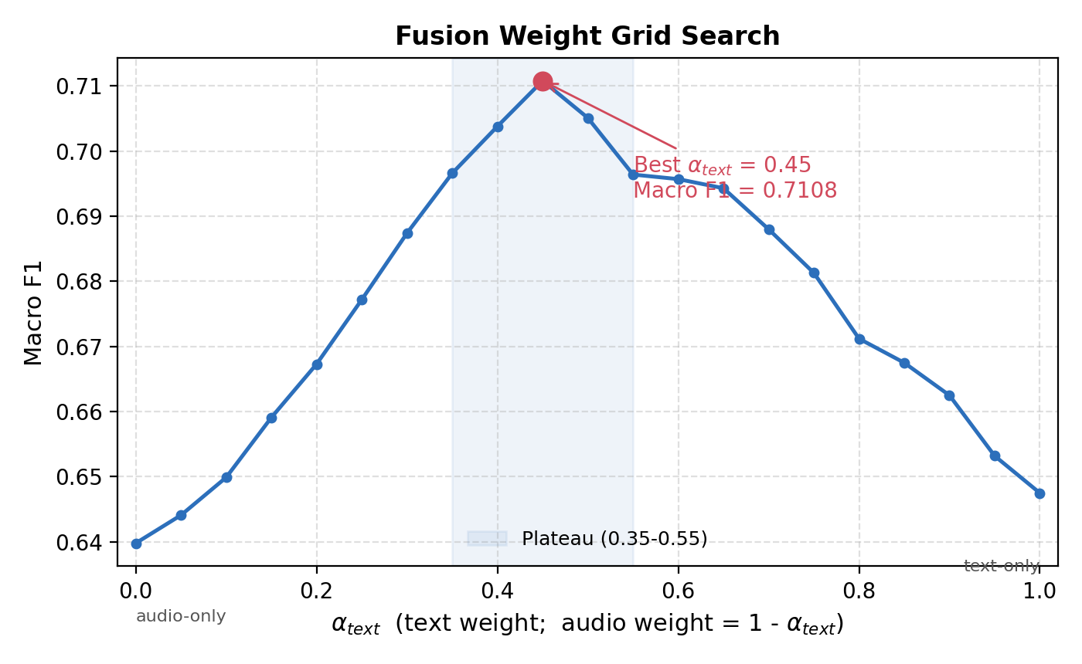
Figure 5. Fusion weight grid search: Macro F1 as a function of the text weight α_text (audio weight = 1 − α_text). The peak at α_text=0.45 (Macro F1=0.7108) is marked; the flat plateau over α ∈ [0.35, 0.55] shows the result is not sensitive to the exact weight.

3.2.4 Strengths, Weaknesses, and Computational Considerations
Text model. Strongest at valence-based distinctions. Weakest on utterances where emotion is expressed purely through tone. Training time: ~45 min on a single GPU (Tesla T4); ~125M parameters.
Audio model. Strongest at arousal-based distinctions (detecting high-energy, high-pitch speech). Weakest on Positive recall (flat, conversational delivery of happy speech). Training time: ~2 hours on a single GPU; ~95M parameters, but larger input tensors require smaller batch size (8 vs. 32 for text).
Late fusion. No training cost evaluation of 21 weight values takes seconds on CPU. The +0.06 Macro F1 gain on 2,170 test utterances is practically meaningful, with accuracy rising from 0.6843 to 0.7502 approximately 143 additional utterances correctly classified.

3.3 Results Interpretation

3.3.1 Error Analysis: Neutral Is the Hardest Class
Neutral speech is defined negatively it is neither clearly positive nor clearly negative. It therefore lacks distinctive vocabulary and distinctive prosodic patterns. Both unimodal models achieve their worst F1 on Neutral (0.46 for text, 0.51 for audio). Fusion improves Neutral F1 to 0.55 (+0.09 over text-only). The key mechanism: the joint absence of strong lexical signal AND strong acoustic arousal signal is itself informative for the Neutral class. Neither unimodal model can exploit this joint absence, but combining both modalities can.

3.3.2 Why Fusion Works: Complementary Error Patterns
The critical condition for fusion to improve over both unimodal baselines is that the two models fail on largely non-overlapping examples. Several lines of evidence support this:
- Different precision/recall trade-offs (Table 6): text achieves higher Negative precision (0.81 vs. 0.80) while audio achieves higher Negative recall (0.77 vs. 0.72). These are complementary strengths on the same class.
- Different error types by construction: text fails when emotional tone is present but wording is neutral. Audio fails when emotional words are clear but vocal delivery is flat. These two error types are largely non-overlapping.
- Magnitude of the fusion gain: +0.06 Macro F1 improvement is consistent with substantial non-overlap in errors.

3.3.3 Ground-Truth Robustness: Sum-then-Argmax

Table 8. Sum-then-Argmax robustness check. Labels flipped: 92/2,170 = 4.24%.
Model | Original Macro F1 | Corrected Macro F1 | Δ
Text-only | 0.6475 | 0.6506 | +0.003
Audio-only | 0.6398 | 0.6359 | −0.004
Late Fusion | 0.7108 | 0.7081 | −0.003

The Δ is below 0.005 for all three models, confirming that the headline results are stable. Only 4.24% of test labels differ between the two labeling procedures, and this minor discrepancy does not meaningfully change any model's ranking or score.

3.3.4 Consensus Tier Analysis

Table 9. Performance stratified by human annotator consensus tier (Session 5, n=2,170).
Model | Tier | N | Accuracy | Macro F1
Text-only | Low (cᵢ < 0.5) | 65 | 0.308 | 0.285
Text-only | Medium (0.50–0.75) | 940 | 0.585 | 0.588
Text-only | High (cᵢ > 0.75) | 1165 | 0.792 | 0.695
Audio-only | Low (cᵢ < 0.5) | 65 | 0.369 | 0.308
Audio-only | Medium (0.50–0.75) | 940 | 0.596 | 0.580
Audio-only | High (cᵢ > 0.75) | 1165 | 0.768 | 0.666
Late Fusion | Low (cᵢ < 0.5) | 65 | 0.385 | 0.344
Late Fusion | Medium (0.50–0.75) | 940 | 0.648 | 0.645
Late Fusion | High (cᵢ > 0.75) | 1165 | 0.851 | 0.766

All three models show strictly monotone improvement from Low to High consensus tier. Model errors are not random they concentrate precisely on the utterances that were intrinsically ambiguous to human annotators.

3.3.5 Feature Drivers per Modality
RoBERTa relies primarily on lexical valence cues emotionally charged words and phrases that carry inherent sentiment polarity. Wav2Vec2 captures prosodic arousal patterns encoded in the raw waveform, including pitch variability, speaking rate, and energy contour. This complementarity is consistent with the fusion weight search result: the optimal α_text=0.45 gives audio a slightly larger share, reflecting audio's stronger per-class discrimination on the Negative class (F1=0.78 vs. 0.76 for text).

4. Conclusions and Discussion

4.1 Answer to the Research Question
Research Question Answer: YES
Can we predict a speaker's emotion using a multimodal approach combining acoustic features and textual content? YES. Late fusion at optimal weight α=0.45 achieves Macro F1 of 0.7108, compared to 0.6475 for text-only and 0.6398 for audio-only a gain of +0.06 requiring no additional training. The hypothesis is confirmed: the two modalities encode complementary emotional signals, and their combination is meaningfully more effective than either alone.

4.2 Key Findings
- Both modalities carry approximately equal emotional signal (~0.64–0.65 Macro F1 unimodal), but they fail on different examples.
- Text captures valence distinctions (positive vs. negative word choice); audio captures arousal distinctions (energetic vs. calm delivery). These strengths are complementary.
- Neutral is the hardest class across all models it lacks distinctive words and prosody. Fusion helps it most (+0.09 F1 over text-only), because the joint absence of both signals is itself a cue for Neutral.
- The optimal fusion weight α_text=0.45 gives audio a slightly larger share despite text scoring marginally higher standalone, reflecting per-class complementarity. A plateau in α ∈ [0.35, 0.55] indicates robustness to the exact value.
- Model errors concentrate on utterances with low human annotator consensus, suggesting the task's irreducible difficulty is shared between models and human raters.
- The Sum-then-Argmax robustness check (Δ < 0.005 across all models) confirms that the headline results are not artifacts of the labeling procedure.

4.3 Limitations
Single held-out session. Using only Session 5 gives one point estimate with no variance measurement. Full 5-fold LOSO cross-validation would provide statistically more robust results but requires ~5× the compute.
3-class grouping. Collapsing 10 emotions into 3 loses nuance. Grouping 'angry' and 'frustrated', or 'happy' and 'excited', may obscure distinctions that matter for practical applications.
Fusion weight selected on test set. The optimal α is identified on the same test set used for final reporting. A held-out validation set would be more principled.
English-only models. RoBERTa and Wav2Vec2 were pre-trained on English data and may not generalize to other languages or recording conditions.

4.4 Future Work
- Attention-based fusion. Replace the fixed α with a learned per-utterance attention weight, allowing the contribution of each modality to vary based on the input.
- Cross-modal attention. Apply the Multimodal Transformer [7] to let text and audio representations attend to each other during inference, capturing interactions that logit-level fusion cannot model.
- Full LOSO cross-validation. Run all 5 folds to obtain variance estimates on all reported metrics.
- Finer-grained labels. Evaluate on a 5-class or 10-class grouping that preserves distinctions between semantically related emotions.

References
[1] C. Busso et al., "IEMOCAP: Interactive emotional dyadic motion capture database," Language Resources and Evaluation, vol. 42, no. 4, pp. 335–359, 2008.
[2] S. Poria et al., "A review of affective computing: From unimodal analysis to multimodal fusion," Information Fusion, vol. 37, pp. 98–125, 2017.
[3] Y. Liu et al., "RoBERTa: A robustly optimized BERT pretraining approach," arXiv:1907.11692, 2019.
[4] L. Pepino et al., "Emotion recognition from speech using wav2vec 2.0 embeddings," in Proc. Interspeech, 2021, pp. 3400–3404.
[5] A. Baevski et al., "wav2vec 2.0: A framework for self-supervised learning of speech representations," in Advances in NeurIPS, 2020.
[6] A. Zadeh et al., "Tensor fusion network for multimodal sentiment analysis," in Proc. EMNLP, 2017, pp. 1103–1114.
[7] Y.-H. H. Tsai et al., "Multimodal Transformer for Unaligned Multimodal Language Sequences," in Proc. ACL, 2019, pp. 6558–6569.
[8] T. Wolf et al., "Transformers: State-of-the-art natural language processing," in Proc. EMNLP (System Demonstrations), 2020, pp. 38–45.
[9] A. Paszke et al., "PyTorch: An imperative style, high-performance deep learning library," in Advances in NeurIPS, 2019.
[10] Q. Lhoest et al., "Datasets: A community library for natural language processing," in Proc. EMNLP (System Demonstrations), 2021, pp. 175–184.

